Anatomy and Physiology of the Digestive and the Endocrine Systems
Digestive and Endocrine Systems
The human digestive system is comprised of the different organs in the gastrointestinal tract, and other digestive accessory organs such as the salivary glands, the pancreas, the tongue, the gallbladder and the liver. The system helps in breaking down the food we consume into smaller components so that it can be absorbed and assimilated into the body.
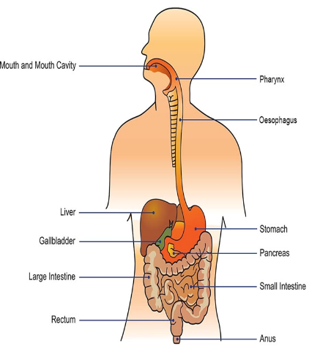
The Digestive System
On the other hand, the endocrine system contains a collection of secretion glands which release hormones that help in regulating growth, metabolism, development of tissues, ability to function sexually, ability to reproduce, change of moods, sleeping and many other functions.
The endocrine systems help in the coordination of the other organ systems which help the body to function through the use of hormones which are chemical signals (Silverthorn, 2015). The endocrine system regulates the digestive system functionalities by secreting the digestive hormones and chemicals.
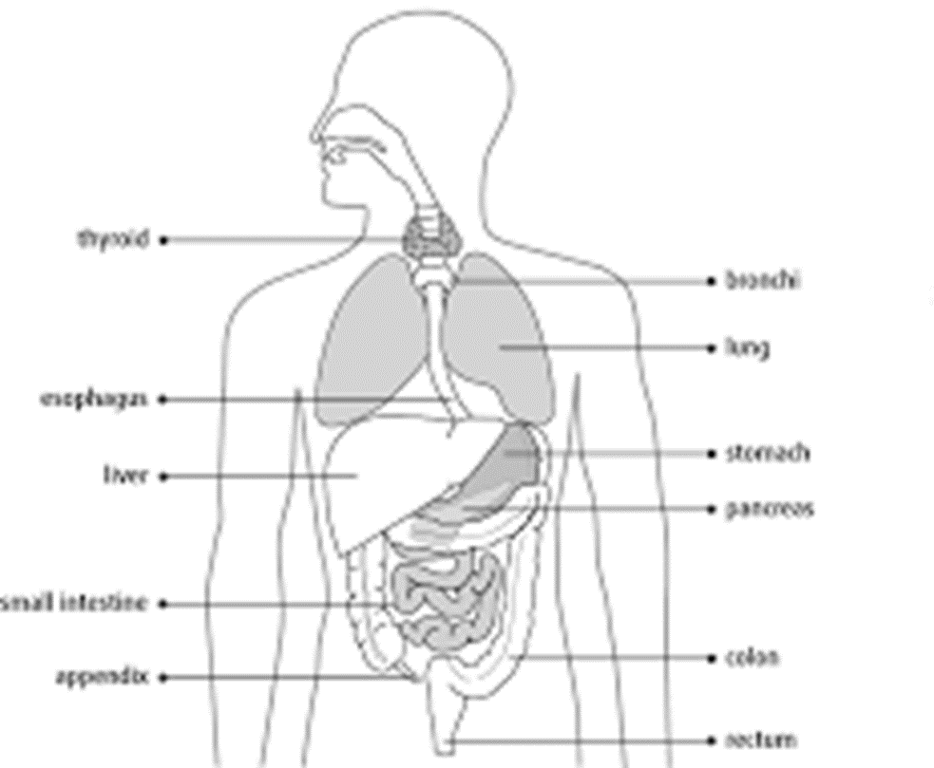
The Endocrine System

Endocrine and Exocrine Glands
Endocrine glands are responsible for the release of chemical substances which are referred to as hormones into the body tissues or into the blood stream directly (de Mestier et al., 2017). The exocrine glands are responsible for the release of the different chemical substances through body ducts which are outside the body or ducts within the body connecting to surfaces in the body.
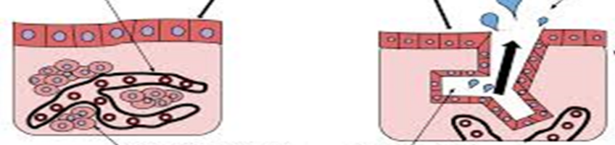
The Endocrine and Exocrine Glands.
Gastrin Hormone
Gastrin hormones are referred to as peptide hormones and they stimulate the secretion of gastric acid that is referred to as HCI. The hormones are secreted by the parietal cells in the stomach and they play a major role in helping gastric motility (Neuman et al., 2015). The main functions of the gastrin hormone include:
Stimulating fundal growth and parietal cell maturation.
Stimulates the secretion of pepsinogen by the chief cells.
Helps in the gastrocolic reflex.
Helps in the relaxation of the ileocecal valve.
Increases the mobility of the antral muscle.
Excessive and Low-Level Production of Gastrin
If the hormone is produced in excessive levels, it might lead to gastrinoma, a gastrin producing tumor. If the hormone is produced in low levels might lead to gastritis, a condition affecting the immune system.

Hormones in Endocrine System
There are many endocrine glands which release hormones that affect the digestive system, however, the most significant control on the digestive system is caused by the endocrine glands in the gastrointestinal tract. The tract is the largest organ in the endocrine system and it releases enteric hormones which include;
Gastrin – released in the stomach and regulates the release of gastric acid.
Cholecystokinin – this is an intestinal hormone which stimulates the release of bile and the pancreatic enzymes.
Secretin – small intestinal hormone that is secreted by the epithelial cells and it helps in the release of fluids which are rich in bicarbonate from the liver and the pancreas.
Planning Survey Questions and Results
In the survey, 8 willing respondents were given questionnaires with questions about the digestion and endocrine system. The questions were aimed at testing the understanding of the participants on digestive and endocrine systems.
The survey questionnaire was sent to the respondents’ emails. Prior to sending of the questionnaire email, respondents were contacted and gave consent to take part in this survey.
The survey questionnaire contained the following questions:
- Do you understand the structure and function of the human digestive system?
☐Yes
☐No
- Do you understand the structure and function of the human endocrine system?
☐ Yes
☐ No
- Does the endocrine system and the digestive system have a relationship?
☐ Yes
☐ No
- If yes, how does the endocrine system and digestive system interact with one another?
_________________________________________________________________
- Do the exocrine glands secrete hormones which are used in the digestion system?
☐ Yes
☐ No
- Do the endocrine glands stimulate the secretion of hormones used in the digestion system?
☐ Yes
☐ No
- Name three hormones or chemical components which help in the digestion of food?
__________________________________________________________________
__________________________________________________________________
__________________________________________________________________
- Which hormone or chemical component listed above is not secreted in the endocrine system?
_________________________________________________________________
From the survey conducted, the following results were obtained. It was found that there are very few people who understand the link between the endocrine system and the digestive system. From the 8 people who responded to the questionnaire, 2 understood the relationship which exists between the endocrine system and the digestive system. 6 did not understand how the systems are related. A majority of the respondents could not be able to name hormones which help in the digestion system, their function and the glands which release them.
The graph below represents the graphical representation of the results which were obtained.

